# Pizza sales SQL Queries

Soniya Shende

MYSQL Queries

A.KPI’s

-- Total Revenue

SELECT

SUM (total_price) AS total_revenue

FROM

pizza_sales;

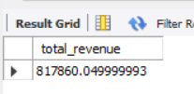

-- Average order value

SELECT

SUM (total_price) / COUNT (DISTINCT order_id) AS Avg_order_value

FROM

pizza_sales;

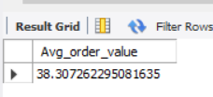

-- Total Pizzas sold

SELECT

SUM (quantity) AS total_pizzas_sold

FROM

pizza_sales;

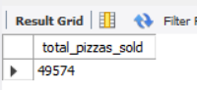

-- Total orders

SELECT

COUNT (DISTINCT order_id) AS total_orders

FROM

pizza_sales;

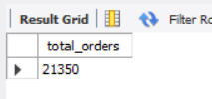

-- Average pizzas per order

SELECT

SUM (quantity) / COUNT (DISTINCT order_id) AS avg_pizzas_per_order

FROM

pizza_sales;

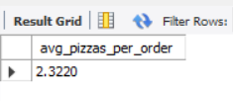

B. Daily Trend for total orders

SELECT

DAYNAME (order_date) AS order_day,

COUNT (DISTINCT order_id) AS total_orders

FROM

pizza_sales

GROUP BY DAYNAME (order_date);

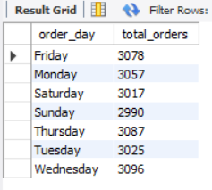

C. Monthly trend for total orders

SELECT

MONTHNAME (order_date) AS order_day,

COUNT (DISTINCT order_id) AS total_orders

FROM

pizza_sales

GROUP BY MONTHNAME (order_date)

ORDER BY total_orders DESC;

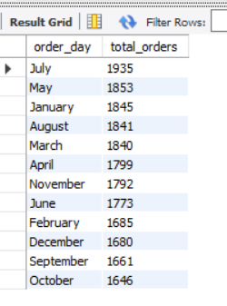

D. Percentage of sales by pizza category

SELECT

pizza_category,

ROUND (SUM (total_price) * 100 / (SELECT

SUM (total_price)

FROM

pizza_sales),

2) AS perc_of_sales

FROM

pizza_sales

GROUP BY pizza_category

ORDER BY perc_of_sales DESC;

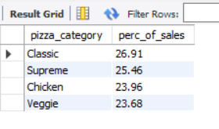

E. Percentage of sales by pizza size

SELECT

pizza_size,

ROUND (SUM (total_price) * 100 / (SELECT

SUM (total_price)

FROM

pizza_sales),

2) AS perc_of_sales

FROM

pizza_sales

GROUP BY pizza_size

ORDER BY perc_of_sales DESC;

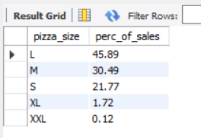

F. Total pizzas sold by pizza category

SELECT

pizza_category, SUM (quantity) AS total_quantity

FROM

pizza_sales

WHERE

MONTH (order_date) = 1

GROUP BY pizza_category

ORDER BY total_quantity DESC;

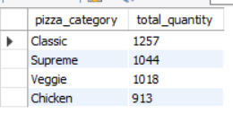

G. Top 5 best sellers by Revenue

SELECT

pizza_name, SUM (total_price) AS total_revenue

FROM

pizza_sales

GROUP BY pizza_name

ORDER BY total_revenue DESC

LIMIT 5;

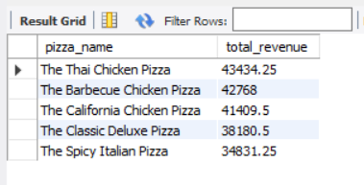

H. Bottom 5 worst sellers by Revenue

SELECT

pizza_name, SUM (total_price) AS total_revenue

FROM

pizza_sales

GROUP BY pizza_name

ORDER BY total_revenue

LIMIT 5;

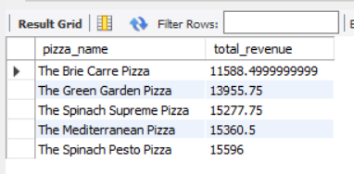

I. Top 5 best sellers by total quantity

SELECT

pizza_name, SUM (quantity) AS total_quantity

FROM

pizza_sales

GROUP BY pizza_name

ORDER BY total_quantity DESC

LIMIT 5;

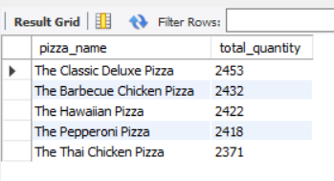

J. Bottom 5 worst sellers by total quantity

SELECT

pizza_name, SUM (quantity) AS total_quantity

FROM

pizza_sales

GROUP BY pizza_name

ORDER BY total_quantity

LIMIT 5;

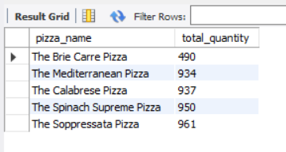

K. Top 5 best sellers by total orders

SELECT

pizza_name, COUNT (DISTINCT order_id) AS total_orders

FROM

pizza_sales

GROUP BY pizza_name

ORDER BY total_orders DESC

LIMIT 5;

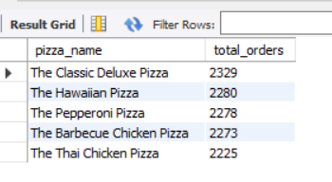

L. Bottom 5 worst sellers by total orders

SELECT

pizza_name, COUNT (DISTINCT order_id) AS total_orders

FROM

pizza_sales

GROUP BY pizza_name

ORDER BY total_orders

LIMIT 5;

